International Health Care
Refugee Crisis
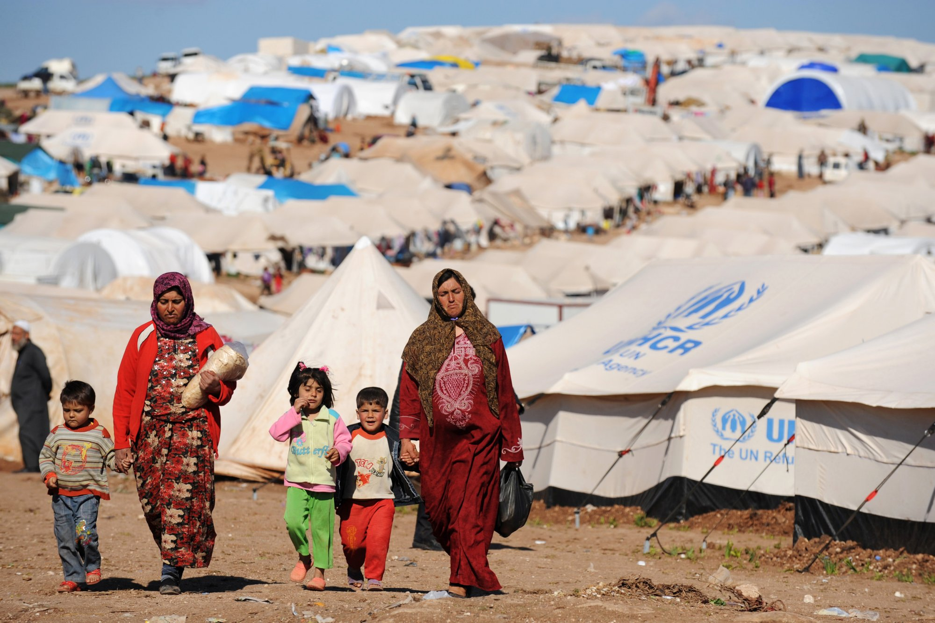
Refugees are people who are forced to flee their countries because of persecution, war or violence. Once these people cross an international border in search of safety, they create an international crisis as more than one government is now involved with their safety. The countries where these refugees seek asylum is often forced to ensure that these people have a safe place to stay and this may entail seeking help from other nations especially the powerful ones like the US and Russia. `the various countries who have given these refugees asylums have done a good job since taking in refugees is often viewed as a security threat since people terror groups may take advantage of such situations to infiltrate into neighboring nations by disguising themselves as refugees.
From the photo of the Syrian refugees’ camps, it is evident that most of the inhabitants of these camps are women and children who are often the most affected during the times of war. Life in this camp seems to be hostile, and from the look at the tents, it is clear that the quality of healthcare in these camps is not of high quality.
Citizens and refugees can be able to help one another to adjust to the new situations. This can be done by the citizens opening their arms for the refugee and stop stereotyping refugees as people who are looking for handouts and welfare. Once people have this type of mindset, then they will be able to realize that the refugees also bring in new opportunities since they increase demand for goods and services which in turn creates employment opportunities.

Works Cited
"CARE |." www.care.org/. "Trump considers using the U.S. military to establish refugee camps in Syria | SOFREP." sofrep.com/73303/trump-considers-using-u-s-military-establish-refugee-camps-syria/.

